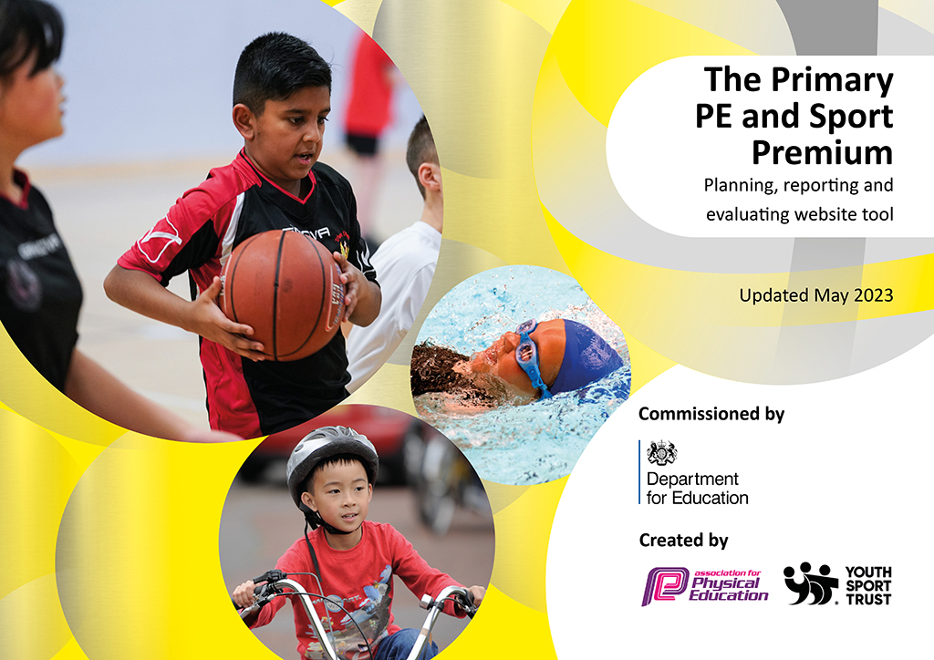
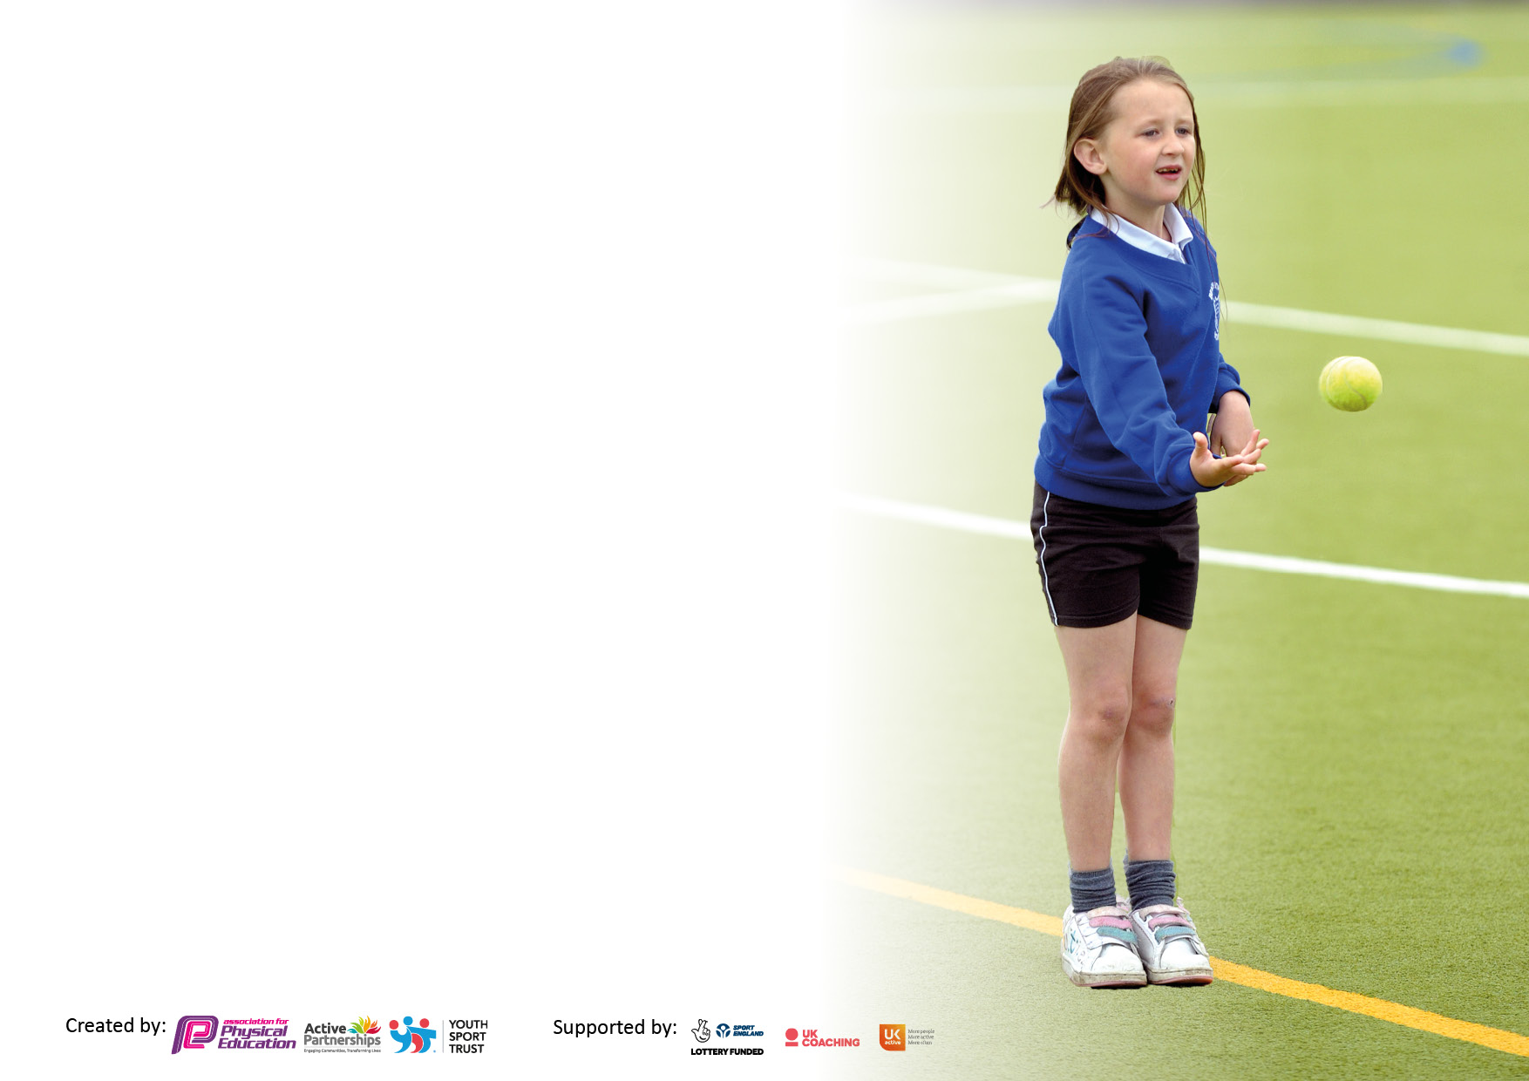

It is important that your grant is used effectively and based on school need. The Education Inspection Framework makes clear there will be a focus on ‘whether leaders and those responsible for governors all understand their respective roles and perform these in a way that enhances the effectiveness of the school’.

Under the Quality of Education Ofsted inspectors consider:
Intent - Curriculum design, coverage and appropriateness
Implementation - Curriculum delivery, Teaching (pedagogy) and Assessment
Impact - Attainment and progress

To assist schools with common transferable language this template has been developed to utilise the same three headings which should make your plans easily transferable between working documents.

Schools must use the funding to make additional and sustainable improvements to the quality of Physical Education, School Sport and Physical Activity (PESSPA) they offer. This means that you should use the Primary PE and sport premium to:

- Develop or add to the PESSPA activities that your school already offer
- Build capacity and capability within the school to ensure that improvements made now will benefit pupils joining the school in future years
- The Primary PE and sport premium should not be used to fund capital spend projects; the school’s budget should fund these.

Please visit gov.uk for the revised DfE guidance including the5keyindicatorsacrosswhichschoolsshoulddemonstrate an improvement. This document will helpyoutoreviewyourprovisionandtoreportyourspend.DfEencouragesschools to use this template as an effective way of meeting the reporting requirements of the Primary PE and Sport Premium.

We recommend you start by reflecting on the impact of current provision and reviewing the previous spend.

Schools are required to publish details of how they spend this funding, including any under-spend from 2021/2022, as well as on the impact it has on pupils’ PE and sport participation and attainment. The funding should be spent by 31st July but the DfE has stated that there will be no clawback of any unspent money so this can be carried forward into 2023/24.

We recommend regularly updating the table and publishing it on your website throughout the year. This evidences your ongoing self-evaluation of how you are using the funding to secure maximum, sustainable impact. Final copy must be posted on your website by the end of the academic year and no later than the 31st July 2023. To see an example of how to complete the table please click HERE.

Details with regard to funding
Please complete the table below.

Total amount carried over from 2021/22 | £0
Total amount allocated for 2021/22 | £19350
How much (if any) do you intend to carry over from this total fund into 2022/23? | £500
Total amount allocated for 2022/23 | £19470
Total amount of funding for 2022/23. Ideally should be spent and reported on by 31st July 2023. | £ 19970
Swimming Data
Please report on your Swimming Data below.

Meeting national curriculum requirements for swimming and water safety.

N.B. Complete this section to your best ability. For example you might have practised safe self-rescue techniques on dry land which you can then transfer to the pool when school swimming restarts.
Due to exceptional circumstances priority should be given to ensuring that pupils can perform safe self rescue even if they do not fully meet the first two requirements of the NC programme of study
What percentage of your current Year 6 cohort swim competently, confidently and proficiently over a distance of at least 25 metres?  N.B. Even though your pupils may swim in another year please report on their attainment on leaving primary school at the end of the summer term 2023.  Please see note above | 77%
What percentage of your current Year 6 cohort use a range of strokes effectively [for example, front crawl, backstroke and breaststroke]?  Please see note above | 74%
What percentage of your current Year 6 cohort perform safe self-rescue in different water-based situations? | 77%
Schools can choose to use the Primary PE and sport premium to provide additional provision for swimming but this must be for activity over and above the national curriculum requirements. Have you used it in this way? | No

Action Plan and Budget Tracking
Capture your intended annual spend against the 5 key indicators. Clarify the success criteria and evidence of impact that you intend to measure to evaluate for pupils today and for the future.

Academic Year: 2022/23 | Total fund allocated: £19970 | Date Updated: 15.7.23
Key indicator 1: The engagement of all pupils in regular physical activity – Chief Medical Officers guidelines recommend that primary school pupils undertake at least 30 minutes of physical activity a day in school |  |  |  | Percentage of total allocation:
 |  |  |  | 45%
Intent | Implementation |  | Impact
Your school focus should be clear what you want the pupils to know and be able to do and about  what they need to learn and to  consolidate through practice: | Make sure your actions to achieve are linked to your intentions: | Funding allocated: | Evidence of impact: what do pupils now know and what can they now do? What has changed?: | Sustainability and suggested next steps:
New P.E. equipment has been ordered to support in the delivery of teaching high quality physical education across all key stages.  New equipment ordered for Reception and Key Stage 1 to support gross and fine motor development in their outdoor learning.  New playground equipment has been ordered to boost physical activity levels during play times.  Pupil Premium pupils attending after school sports clubs.  Children identified as being the least active attended a weekly movement activity.  Children to engage in a wider experience of sport outside of PE lessons. | Teachers regularly use appropriate equipment within their lessons based upon GS4PE.  Equipment can also be used during lunchtimes to increase regular physical activity.  New equipment is used within continuous provision to support fine and gross motor development.  Used during sensory circuits first thing in the morning to help develop motor skills.  Offer places to Pupil Premium children in the first instance before opening places up to rest of the school.  A new Sports Coach worked with the identified children to engage and motivate the children while trying new activites.  Sports coaches to run lunch time clubs for children in both KS1 and KS2. | £3850  £870  £400  £200  £600  £3000 | Pupils have made improved progress as equipment is functioning as it should be.  Teachers are spending less time in the organising of equipment for their P.E. lessons ensuring more time is spent planning and delivering lessons.  Pupils have engaging equipment that encourages all  levels of physical development.  Children will have access to a  range of high-quality equipment  that exposes them to a range of  sporting activities.  Children had the opportunity to  take part in external clubs that  they would not have previously been able to and take part in regular physical activity.  Children who are the least active have an opportunity to engage with sport in a smaller, more targeted group.  Anecdotal evidence suggested that a high proportion of these children enjoyed the smaller group session for sport and engaged more fully in these sessions that in class PE.  Lunchtimes have become more successful with a high proportion of children being able to engage with sport during this time. | Complete equipment audit to ensure no equipment has been lost or damaged.  Replace any faulty equipment.  Complete equipment audit to ensure no equipment has been lost or damaged.  Replace any faulty equipment.  Review equipment to ensure pupils continue to make progress in fine and gross motor development.  Review playtime equipment with Lunchtime leaders and behaviour lead.  Identify PP pupils to target for next academic year.  Ensure they are signed up for at least one club at the start of the academic year.  Continue to track and monitor these children in the new academic year to track engagement in PE lessons.  Continue to offer lunchtime sports in the next academic year.
Key indicator 2: The profile of PESSPA being raised across the school as a tool for whole school improvement |  |  |  | Percentage of total allocation:
 |  |  |  | 1%
Intent | Implementation |  | Impact
Your school focus should be clear what you want the pupils to know and be able to do and about  what they need to learn and to  consolidate through practice: | Make sure your actions to achieve are linked to your intentions: | Funding allocated: | Evidence of impact: what do pupils now know and what can they now do? What has changed?: | Sustainability and suggested next steps:
Sports Crew training provided by Surrey Active. Pupils will then be confident to deliver and assist in the delivery of P.E. lessons across the school. | 8 Sports Crew have weekly slots to support in the delivery of physical education and develop play time games to ensure it is more active.  Can also be used to support pupil voice – part of the training includes this. | £225 | P.E. lessons are more structured due to increased support, particularly in EYFS and KS1.  Pupils ensure the sports provision with the school is inspiring the pupils to participate and is reflective of their requests and requirements.  Pupils have increased confidence in teaching physical education, developing leadership, teamwork and communication skills. | Ensure new Year 5 pupils are selected for the sports crew training.  Organise timings with current sports crew to assist with delivery of P.E. with sports coach for the next academic year.

Key indicator 3: Increased confidence, knowledge and skills of all staff in teaching PE and sport |  |  |  | Percentage of total allocation:
 |  |  |  | 8%
Intent | Implementation |  | Impact
Your school focus should be clear | Make sure your actions to | Funding | Evidence of impact: what do | Sustainability and suggested
what you want the pupils to know | achieve are linked to your | allocated: | pupils now know and what | next steps:
and be able to do and about | intentions: |  | can they now do? What has
what they need to learn and to |  |  | changed?:
consolidate through practice:
Upon consulting with other Kite schools, GS4PE scheme of learning was purchased and implemented. GS4PE is portable Physical Education planning, assessment and tracking tool designed to enable all Primary School teachers to deliver enjoyable, active and high-quality sessions. The scheme is child centered and allows pupils' achievement’s to be tracked from Nursery to Year 6.  Gymnastic CPD provided by external provider to increase staff confidence in teaching gymnastics.  Raise the profile of sports within the school by having an inspirational speaker (Ex England basketball player) come into school. | A tailored and progressive curriculum map was developed using the scheme.  Teachers and sports staff have followed the scheme to ensure consistency.  Gymnastics was identified as an area of low confidence amongst staff members.  Training to be provided at the start of the 23/24 academic year.  The guest speaker hosted an assembly for all children (Reception to Year 6) and a workshop for each year group to inspire competitive sport and a lifelong passion for physical activity. | £550  £500  £450 | Ensures full coverage against the national curriculum objectives.  Pupils have developed key knowledge and skills provided through this scheme.  It has given staff a  progressive scheme to support  their teaching, as well as  progression and support for those who need it.  Staff will feel increasingly confident in teaching of gymnastics.  Pupils will make improved progress in this area of the curriculum due to increased knowledge from staff.  Pupils feel empowered to compete in competitive sport.  Pupils spoke passionately about their motivation to take part in physical activity. | Review staff audit to assess impact of training.  P.E. lead to observe teaching of gymnastics.
Key indicator 4: Broader experience of a range of sports and activities offered to all pupils |  |  |  | Percentage of total allocation:
 |  |  |  | 23%
Intent | Implementation |  | Impact
Your school focus should be clear | Make sure your actions to | Funding | Evidence of impact: what do | Sustainability and suggested
what you want the pupils to know | achieve are linked to your | allocated: | pupils now know and what | next steps:
and be able to do and about | intentions: |  | can they now do? What has
what they need to learn and to |  |  | changed?:
consolidate through practice:
Skateboard training provided by Team Rubicon to introduce new provision at lunchtime.  New P.E. equipment has been ordered to broaden pupil’s experiences in a range of sports not previously offered. | Each class had a 1 hour session with qualified skateboarding instructor.  PP and SEND pupils also had an extra hour with the instructor.  A range of new sports and physical activities (for example, golf, badminton, yoga, scootering, skateboarding). | £1000  £3500 | Pupils now feel confident to take part in lunchtime skateboarding provision. Physical activity levels will increase as a result of this.  Pupils were motivated to try new activities after feeling successful during the training.  Pupils are offered a broader range of sports and physical activities.  Physical activities are increased as a result. | Book training again for following academic year to ensure skills and knowledge are developed.  Ensure new Year 3 children have the training.  Review offering to pupils and suggest alternative activities.  Reach out to national bodies and local sports clubs to enquire about them offering support and coaching.

Key indicator 5: Increased participation in competitive sport |  |  |  | Percentage of total allocation:
 |  |  |  | 5%
Intent | Implementation |  | Impact
Your school focus should be clear | Make sure your actions to | Funding | Evidence of impact: what do | Sustainability and suggested
what you want the pupils to know | achieve are linked to your | allocated: | pupils now know and what | next steps:
and be able to do and about | intentions: |  | can they now do? What has
what they need to learn and to |  |  | changed?:
consolidate through practice:
Registration fee to cover costs of joining local inter school sporting competitions body.  Teacher cover costs to allow member of staff to attend fixtures. | Joining as enabled weekly sporting matches and competitions across a range of sports. Pupil premium and SEND pupils were selected for every fixture.  Fixtures are split into 3 groups to ensure a range of pupils compete in regular competitive sport.  Matches include football, netball, cross country, tag rugby, athletics, swimming, cricket and dance.  Teacher/ adult to be able to support the children in attending inter-school tournaments and fixtures to enable them to experience competitive sport and try new sports. | £150  £870 | Increased number of pupils have taken part in competitive sport due to large range of sports offered.  A wide range of children from KS1 and 2 have experience of competitive sports in a fun but safe environment. | Continue with registration next academic year to continue allowing the opportunity for pupils to take part in competitive sport.  Continue with this next academic year.

Signed off by
Head Teacher: | S. Armstrong
Date: | 11.7.23
Subject Leader: | J. Prior
Date: | 11.7.23
Governor: | J. Gillum
Date: | 15.7.23

